**INTRODUCTION TO JAVA COLLECTIONS**

**Date 17/02/2021**

1. **Write Java code to define List . Insert 5 floating point numbers in List, and using an iterator, find the sum of the numbers in List.**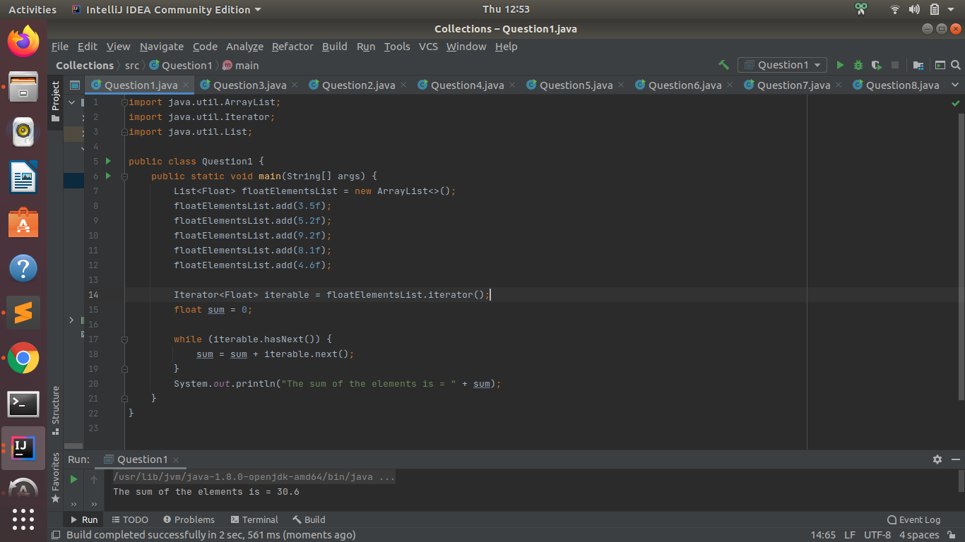
2. **Write a method that takes a string and returns the number of unique characters in the string.**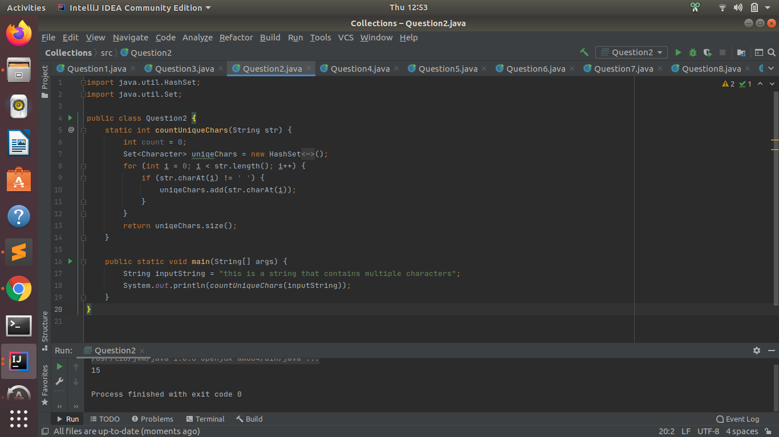
3. **Write a method that takes a string and print the number of occurrence of each character characters in the string.**

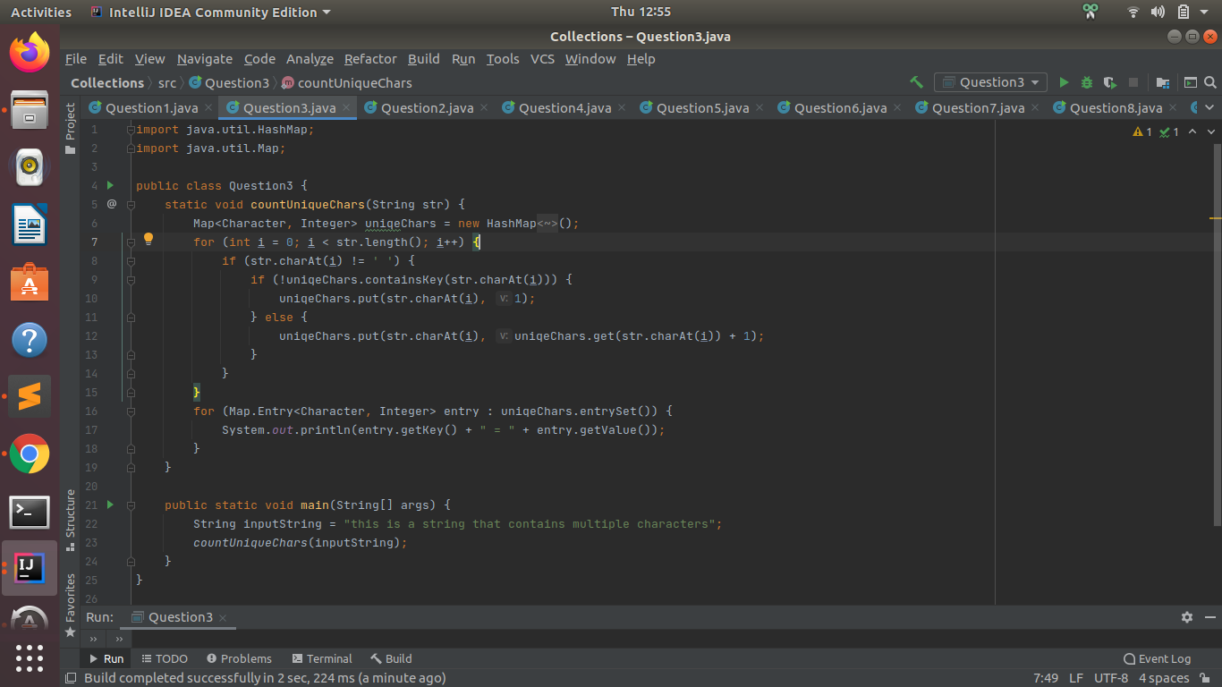

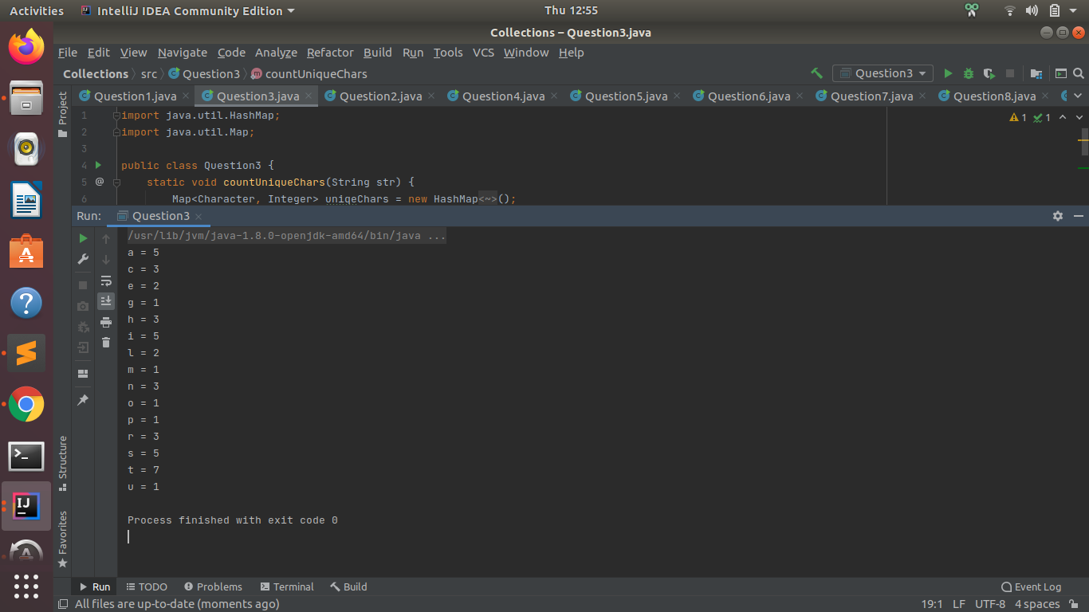

1. **Write a program to sort Employee objects based on highest salary using Comparator. Employee class{ Double Age; Double Salary; String Name**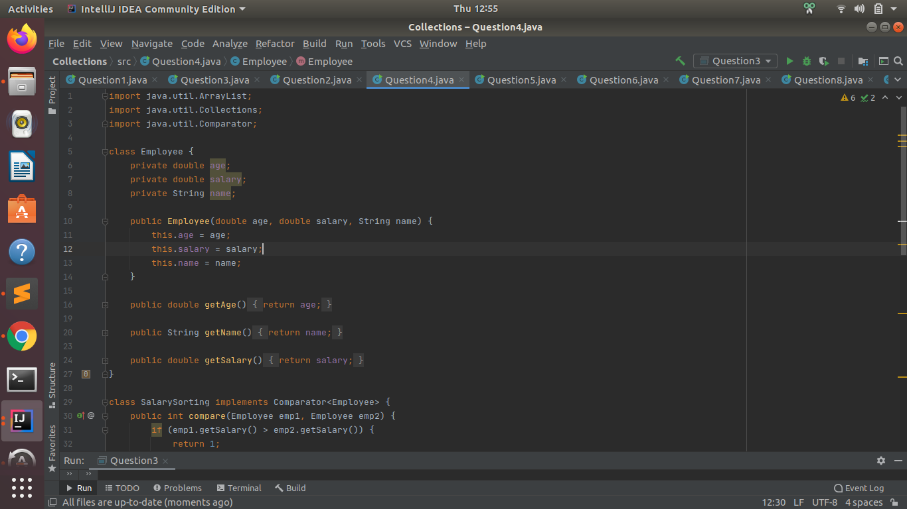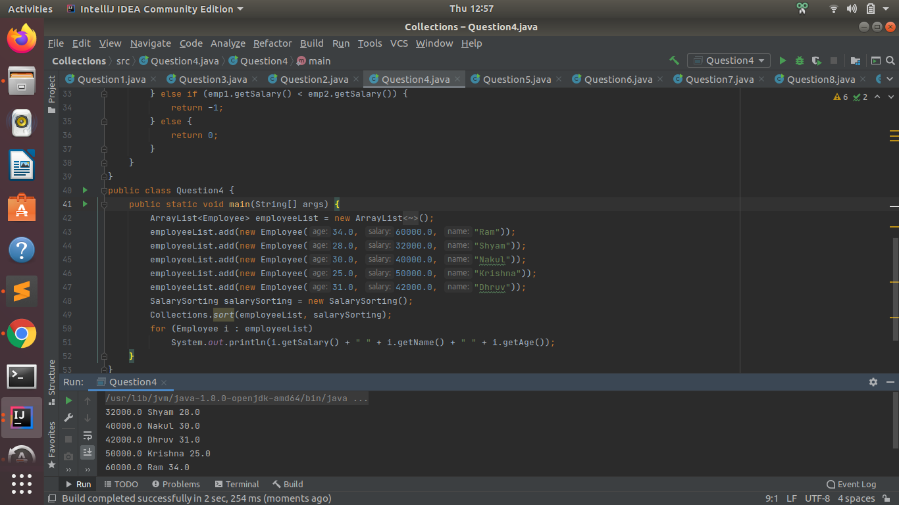
2. **Write a program to sort the Student objects based on Score , if the score are same then sort on First Name . Class Student{ String Name; Double Score; Double Age.**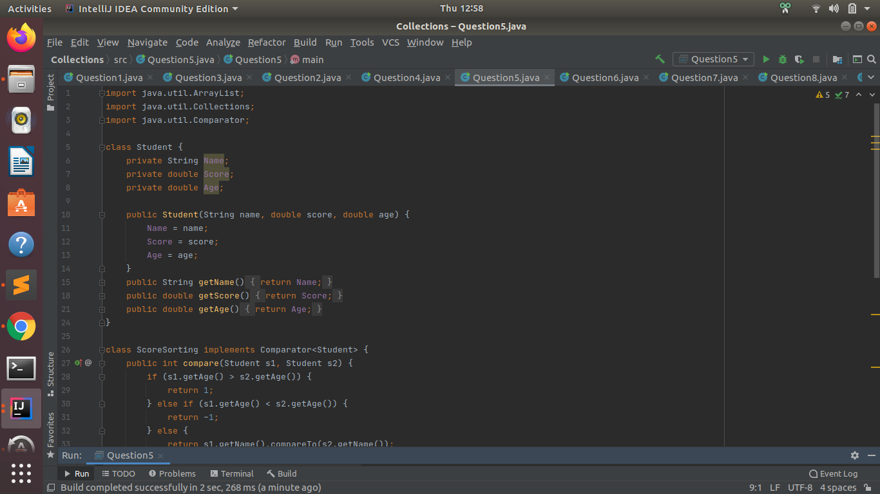

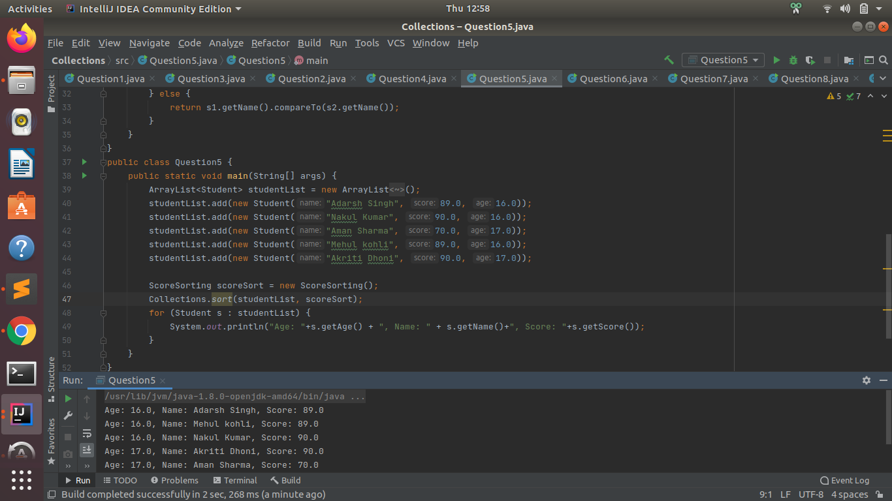

1. **Print the elements of an array in the decreasing frequency if 2 numbers have same frequency then print the one which came first.**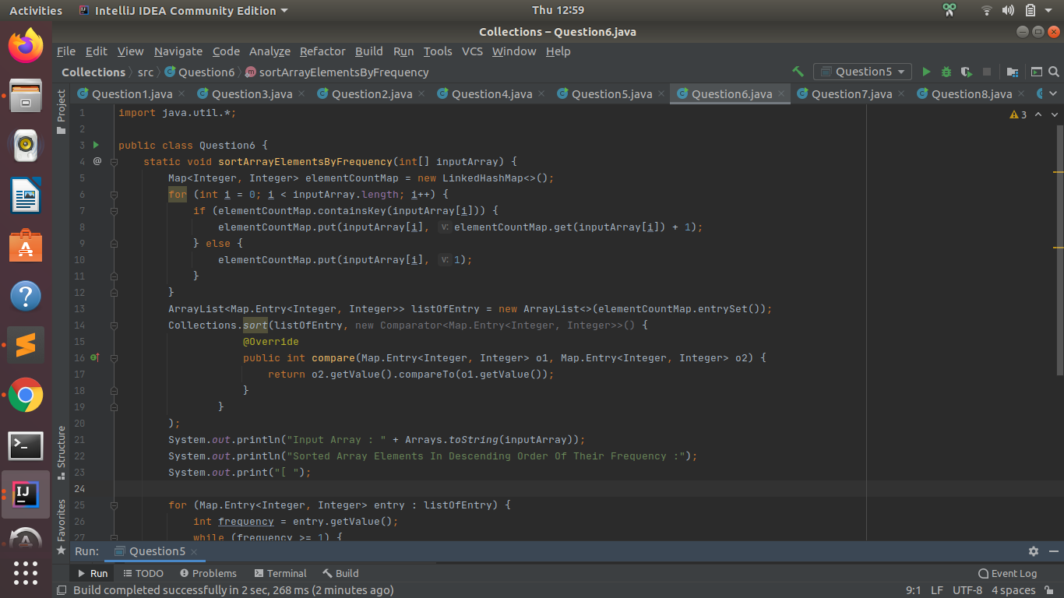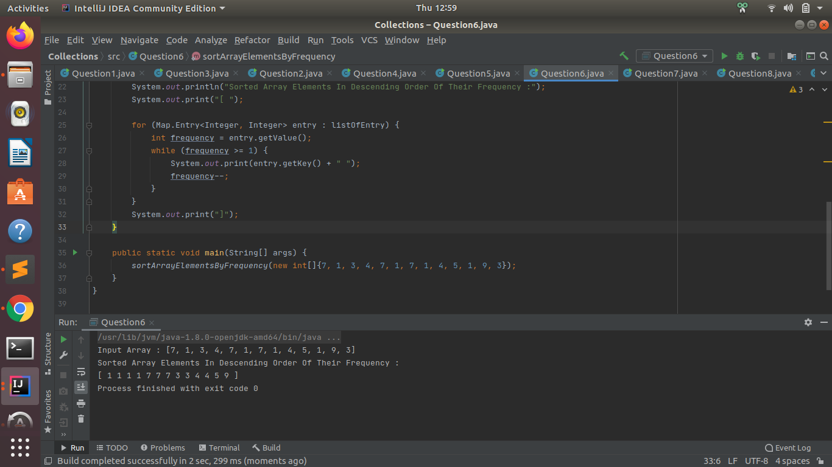
2. **Design a Data Structure SpecialStack that supports all the stack operations like push(), pop(), isEmpty(), isFull() and an additional operation getMin() which should return minimum element from the SpecialStack. (Expected complexity ­ O(1)).**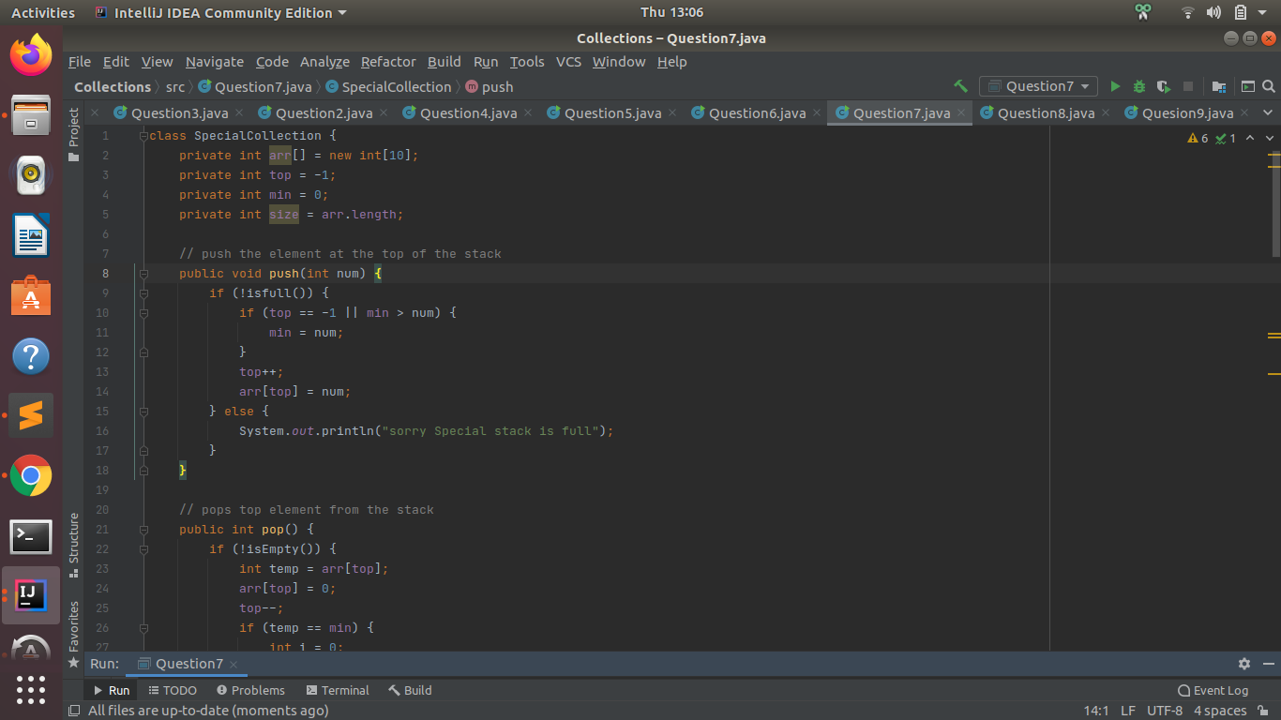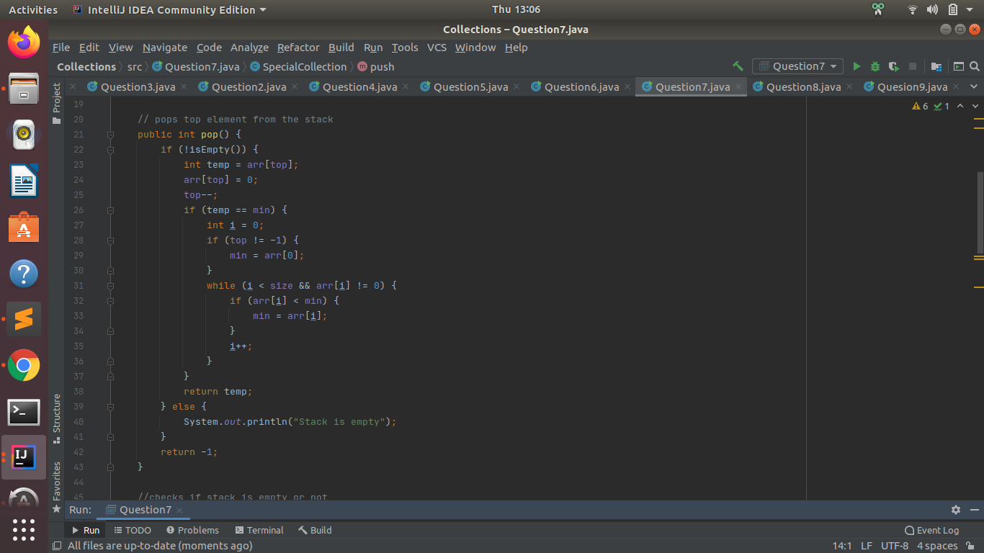

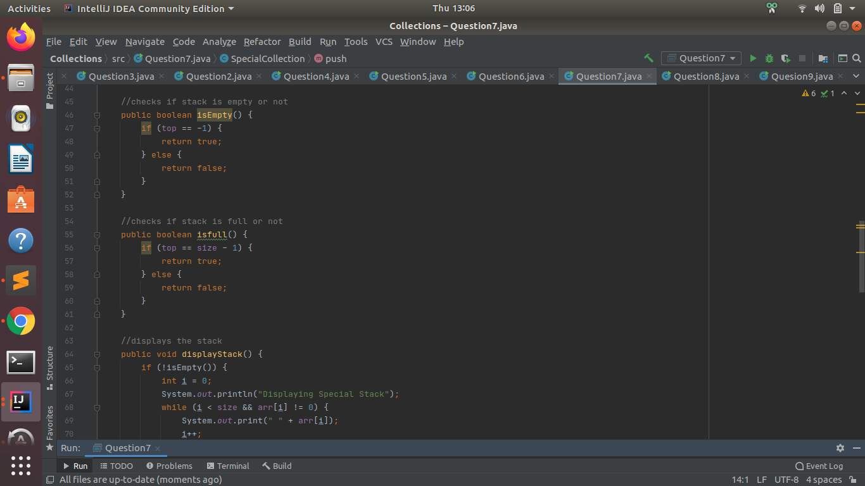

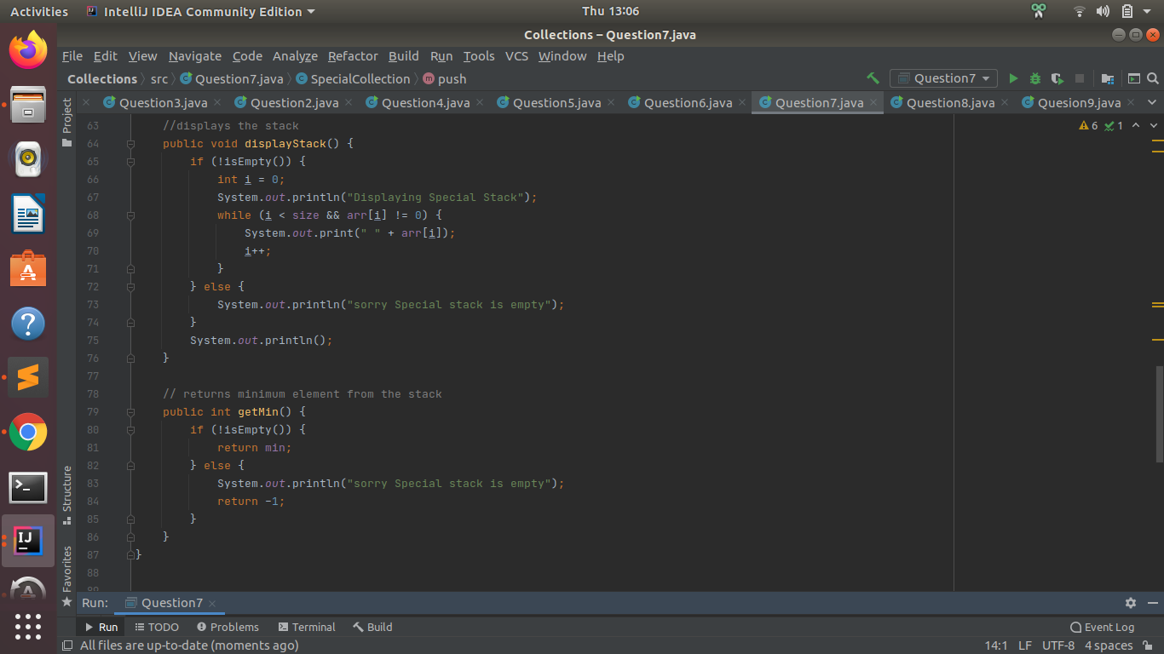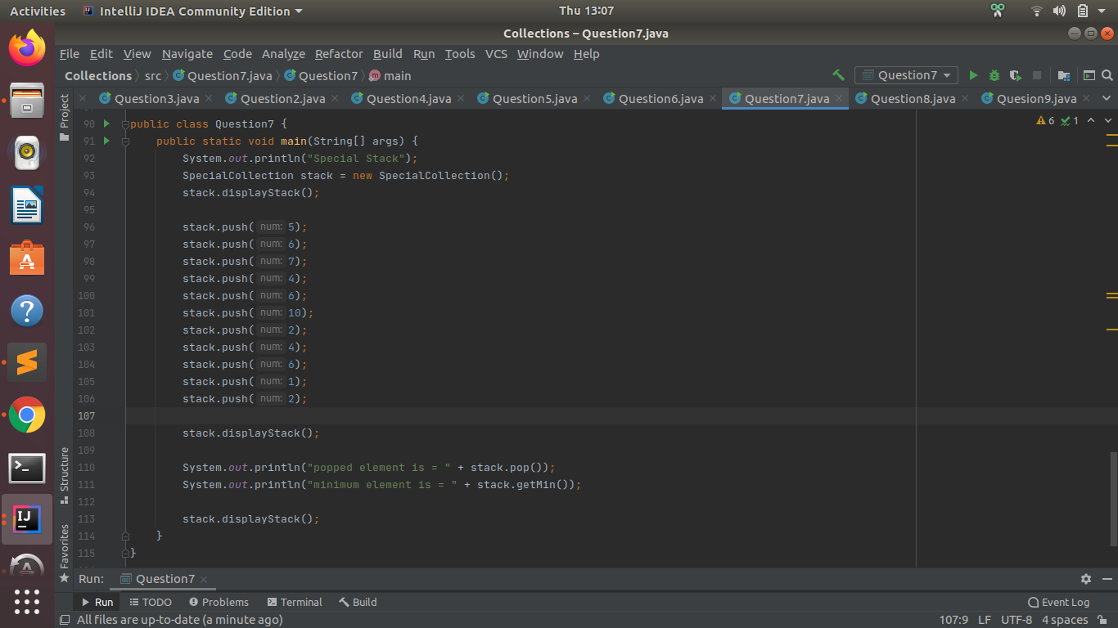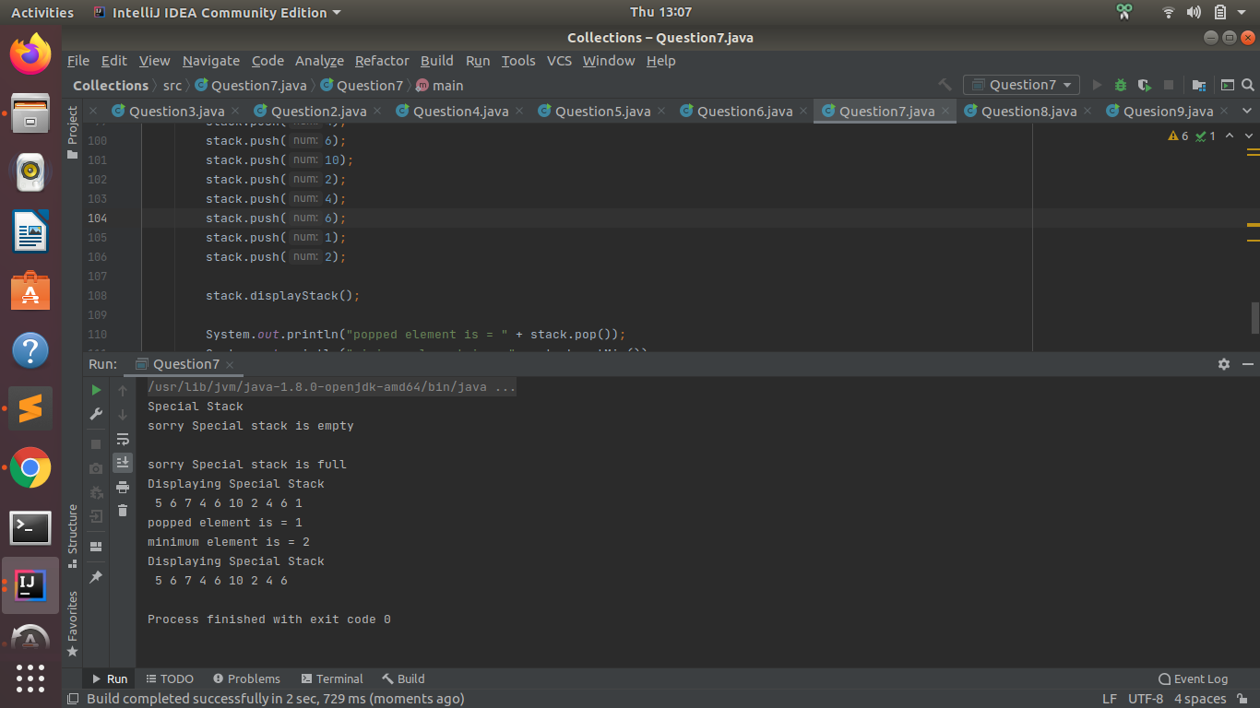

1. **Write a program to format date as example "21-March-2016"**

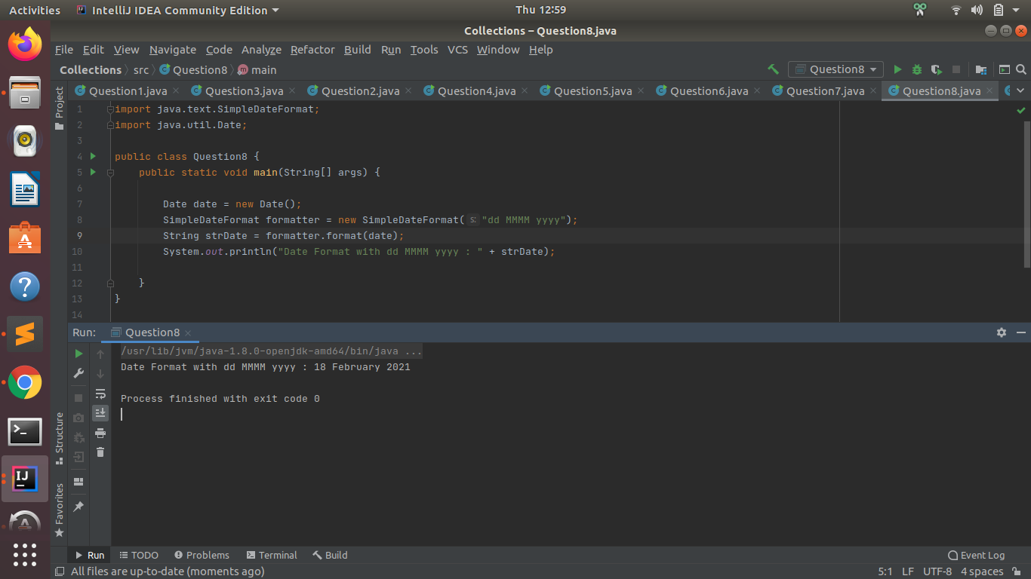

1. **Write a program to display times in different country format.**

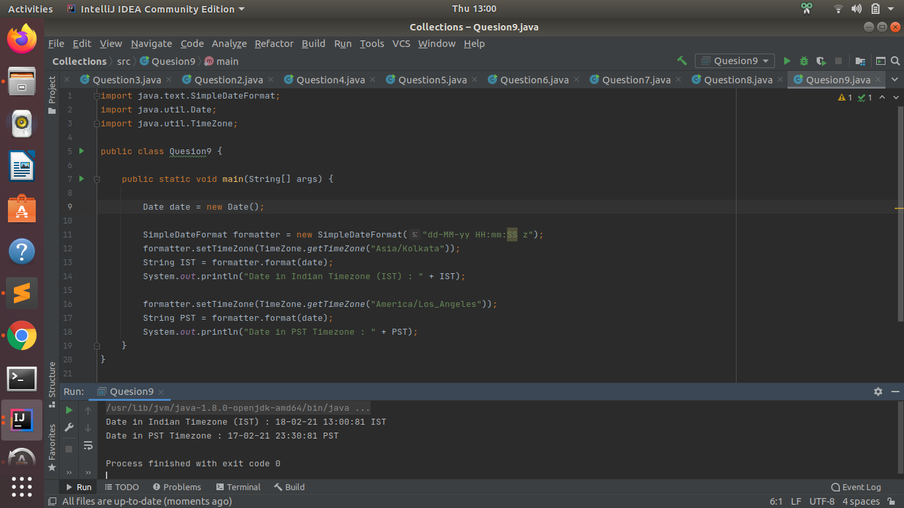

**Google doc link:** [**https://docs.google.com/document/d/1O7ndHxdPtP2FH55qmzOavN6sIJ4CT05AIq7DiDjVtOM/edit?usp=sharing**](https://docs.google.com/document/d/1O7ndHxdPtP2FH55qmzOavN6sIJ4CT05AIq7DiDjVtOM/edit?usp=sharing)